FitTrack AI Backend – Project Description

Date | 24 September 2026
Team ID | SWTID-2026-4802
Project Name | FitTrack

The FitTrack AI Backend is a fitness application backend developed to help users manage their workouts and receive personalized fitness suggestions. It is built using Node.js, Express.js, MongoDB, and Mongoose.
The backend provides APIs for important features such as user registration and login, workout management, workout searching, and fitness recommendations. Users can securely create an account, log in, add their workout details, and view their workout information.
The application uses JWT (JSON Web Token) for secure user authentication. This ensures that only authorized users can access protected features. User passwords are protected using bcrypt.js, which securely hashes passwords before storing them in the MongoDB database.
The project also includes Google Gemini AI to provide personalized workout recommendations. The AI uses information such as the user's age, fitness goal, and workout experience to suggest suitable workouts. It can also analyze workout information such as number of workouts, workout duration, and calories burned to provide useful fitness insights.
The backend is organized using the MVC architecture, which separates the application into different parts and makes the code easier to understand, maintain, and update.
The application also includes input validation, error handling, protected routes, and standardized JSON responses. Because it provides REST APIs, the backend can be connected to different applications such as websites, mobile apps, or other services.
In simple terms, FitTrack AI is a secure fitness backend that stores workout information, manages users, and uses AI to give personalized fitness recommendations and insights.
FitTrack AI – Outcome:
The FitTrack AI backend makes workout tracking easier for users. Instead of writing workout details manually, users can store and manage their workout information through the application.
The system also uses AI to give personalized workout suggestions based on the user's information and workout activities. Secure login and authentication ensure that users can access only their own protected data.
The project uses MVC architecture, which keeps different parts of the application separate. This makes the system easier to understand, maintain, and modify.
In the future, more features can be added without changing the entire system. Some possible features are:
- Nutrition and diet tracking
- BMI calculation
- Smartwatch and wearable-device integration
- Workout reminders
- Fitness progress tracking
- Fitness analytics dashboards

1. Software Requirements
The following software is required to develop and run the FitTrack AI backend.
Operating System
The application can run on:
- Windows 10/11
- macOS
- Linux
Node.js
Node.js is used to run the backend JavaScript code and create the server.

npm
npm (Node Package Manager) is used to install and manage the packages required by the project.
Express.js
Express.js is used to create the backend server and REST APIs. It also handles routes and requests.
MongoDB
MongoDB is the database used to store user and workout information.
Mongoose
Mongoose helps the Node.js application communicate with MongoDB and provides a simple way to work with database data.
Postman
Postman is used to test the APIs. It helps check whether the APIs are working correctly and returning the expected responses.
Code Editor
A code editor such as Visual Studio Code (VS Code) can be used to write and manage the project code.
2. Hardware Requirements:
The following hardware is recommended for developing and running the project:
- Processor: Intel Core i5 8th Generation or above / AMD Ryzen 5 or equivalent
- RAM: Minimum 8 GB; 16 GB is recommended
- Storage: At least 1 GB of free space
Epic 1: Project Architecture:
FitTrack AI uses the MVC (Model-View-Controller) architecture.
In simple terms, MVC divides the application into different sections, where each section has a specific job. This prevents all the code from being placed in one file and makes the project easier to manage.
The main parts of the architecture are:
Client → Express Server → Routes → Middleware → Controllers → Services → Database / AI
For example, when a user sends a request to add a workout:
- The user sends the request from the application.
- The Express server receives the request.
- The request goes to the correct route.
- If the route is protected, the JWT token is checked.
- The controller processes the request.
- The service performs the required operation.
- Mongoose communicates with MongoDB.
- The result is sent back to the user as a JSON response.
For AI-related requests, the controller sends the required information to the Google Gemini AI service, receives the AI response, and sends it back to the user.
Main Architecture Components
The main components of FitTrack AI are:
- Client Application – React app, mobile app, or Postman
- Express Server – Handles incoming requests
- API Routes – Defines available endpoints
- Authentication Middleware – Checks user authentication
- Controllers – Handles application operations
- Services – Contains reusable business logic
- Google Gemini AI Service – Provides AI recommendations
- Mongoose Models – Defines database structures
- MongoDB Database – Stores application data
Each component has its own responsibility. This makes the application easier to update and expand.
Components and Their Functions
1. Client Layer
The Client Layer is the part that users interact with. It can be a website, mobile application, or Postman.
The client sends requests to the backend and receives responses from it.

Responsibilities
- Sends requests to the backend
- Displays workout information
- Stores the JWT token after login
- Requests AI workout recommendations
- Displays success and error messages

APIs Used
- Authentication APIs
- Workout APIs
- AI Recommendation APIs
- AI Fitness Insight APIs
2. Express Server
The Express Server is the main entry point of the backend.
It receives requests from the client and sends them to the correct part of the application.

Responsibilities
- Starts the backend server
- Receives HTTP requests
- Reads JSON data
- Enables CORS
- Connects different routes
- Connects middleware
- Handles errors
- Sends responses to the client
Simple Flow:
Client Request → Express Server → Process Request → Send Response
3. Authentication Middleware:
Authentication middleware is responsible for checking whether the user is logged in and authorized.
When a user accesses a protected API, the request contains a JWT token. The middleware checks whether the token is valid.
Responsibilities
- Reads the Authorization header
- Gets the JWT token
- Checks whether the token is valid
- Gets the user's information from the token
- Allows the request if the token is valid
- Rejects the request if the token is invalid
Benefits
- Protects user information
- Prevents unauthorized access
- Secures workout data
- Avoids writing authentication code repeatedly in every controller

Simple Example
Login → JWT Token Generated → User Sends Token → Middleware Checks Token → Access Granted
4. Route Layer:
Routes define which API should be called for each operation.For example, there can be separate routes for login, adding workouts, searching workouts, and getting AI recommendations.
Authentication Routes:
- Register User
- Login User
- Get User Profile
Workout Routes:
- Add Workout
- Get All Workouts
- Search Workouts
- Get Workout by ID
- Update Workout
- Delete Workout
AI Routes:
- Get Workout Recommendation
- Get Fitness Insights

5. Controller Layer:
Controllers handle the main operations of the application.
When a request comes from a route, the controller decides what needs to be done and sends the final response to the user.
Authentication Controller
Handles:
- User registration
- User login
- User profile
Workout Controller
Handles:
- Adding workouts
- Viewing workouts
- Updating workouts
- Deleting workouts
- Searching workouts
AI Controller
Handles:
- Sending user information to Gemini AI
- Receiving AI recommendations
- Sending AI results back to the client

6. Service Layer:
The Service Layer contains reusable functions and business logic.
Instead of putting all the code inside controllers, important operations are placed inside services. This keeps the code clean and organized.

Gemini AI Service
Handles:
- Creating AI prompts
- Sending prompts to Google Gemini
- Receiving AI responses
- Formatting AI recommendations

JWT Service
Handles:
- Creating JWT tokens
- Setting token expiration
- Verifying tokens

Password Service
Handles:
- Hashing passwords using bcrypt
- Comparing passwords during login
7. Database Layer:
The Database Layer is responsible for storing the application's information.
FitTrack AI uses MongoDB as its database and Mongoose to communicate with MongoDB.

Main Collections
- Users – Stores user information
- Workouts – Stores workout information

Benefits of MongoDB
- Easy to store and retrieve data
- Flexible database structure
- Good performance
- Can handle large amounts of data
- Can be expanded easily in the future
Simple Overall Flow:
The complete FitTrack AI backend can be understood like this:
User / Mobile App / React App
↓
Express Server
↓
API Route
↓
JWT Authentication (if required)
↓
Controller
↓
Service
↓
MongoDB or Google Gemini AI
↓
JSON Response
↓
User
In Simple Words:
FitTrack AI is a backend system that receives requests from users, checks their authentication, processes their workout information, stores data in MongoDB, and uses Google Gemini AI to provide personalized fitness recommendations.
This version is suitable for a project report, and you can also explain the architecture in your viva using the “Simple Overall Flow” section.
Sure. Here is the same content rewritten in very simple English, with less complicated technical language. This version is good for a project report and viva explanation.
Entity Relationship (ER) Diagram:
The FitTrack AI backend mainly uses two collections in MongoDB:
- User
- Workout
These two collections are connected using a one-to-many relationship.
This means one user can have many workout records, but each workout belongs to only one user.

1. User Entity:
The User collection stores the user's account and basic profile information.

User Fields
Field | Type | Purpose
_id | ObjectId | Unique ID of the user
name | String | Stores the user's name
email | String | Stores the user's email
password | String | Stores the encrypted password
createdAt | Date | Date when the account was created
updatedAt | Date | Date when the account was last updated

Rules
- Every user must provide a name.
- The email must be unique.
- The password is encrypted using bcrypt before being stored.
- After successful login, a JWT token is generated.
- The JWT token is used to access protected APIs.
2. Workout Entity:
The Workout collection stores information about the workouts performed by users.

Workout Fields
Field | Type | Purpose
_id | ObjectId | Unique ID of the workout
user | ObjectId | ID of the user who created the workout
workoutName | String | Name of the workout
category | String | Type or category of workout
duration | Number | Workout duration in minutes
caloriesBurned | Number | Calories burned during workout
workoutDate | Date | Date of the workout
createdAt | Date | Date when the record was created
updatedAt | Date | Date when the record was updated
Relationship Between User and Workout:
The relationship is:
User → Workout

Relationship Type: One-to-Many
One user can create many workout records.
For example, a user named John can have:
- Morning Running
- Evening Jogging
- Cycling
- Upper Body Workout
But each workout is connected to only one user.
This connection is created using the user field in the Workout collection. The field stores the user's unique ObjectId.

Simple Example
User
John Doe
|
|---- Morning Running
|
|---- Evening Jogging
|
|---- Cycling
|
|---- Upper Body Workout
So, the User is the main entity, and the Workout records are connected to that user.
Key Features of FitTrack AI
1.Secure User Login:
FitTrack AI provides secure user authentication.
Users can:
- Create an account
- Login
- Use a protected password
- Receive a JWT token
- Access protected APIs
The password is stored in encrypted form, and JWT is used to verify the user's identity.
2. Workout Management:
Users can completely manage their workout records.
This is called CRUD operations:
- Create – Add a new workout
- Read – View workouts
- Update – Change workout details
- Delete – Remove a workout
Each workout is connected to the user who created it.
3. Workout Search:
Users can easily find their workouts by searching using:
- Workout name
- Workout category
- Workout date
For example, a user can search for "Running" to find all running-related workouts.
4. Google Gemini AI:
FitTrack AI uses Google Gemini AI to provide personalized workout suggestions.
The user provides information such as:
- Age
- Fitness goal
- Experience level
The AI then provides:
- Weekly workout plan
- Exercise suggestions
- Training tips
- Safety recommendations
This helps users create a workout plan that matches their needs.

5. AI Fitness Insights:
The application can also use AI to understand the user's workout performance.
The system provides information such as:
- Total number of workouts
- Average workout duration
- Calories burned
The AI uses this information to generate:
- Performance analysis
- Improvement suggestions
- Motivational advice
- Fitness progress summary
For example, if a user has been exercising regularly, the AI can provide a summary of their workout progress.
6. Error Handling:
The application provides proper error messages when something goes wrong.
It can handle errors such as:
- Incorrect login details
- Missing JWT token
- Invalid input
- Database problems
- Server errors
Instead of showing confusing technical errors, the backend returns a clear JSON response.

7. REST API:
FitTrack AI follows the REST API approach.
The main HTTP methods used are:
Method | Purpose
GET | Get or view data
POST | Create new data
PUT | Update existing data
DELETE | Delete data
The backend sends the results in JSON format, which makes it easy for websites and mobile applications to use the APIs.
8. Modular Project Structure:
The project is divided into different sections based on their responsibilities.
These include:
- Models – Manage database structures
- Controllers – Handle application operations
- Routes – Define API endpoints
- Middleware – Check authentication and other requests
- Services – Handle reusable business logic
- Configuration – Manage application settings
This structure makes the project easier to understand, maintain, test, and expand.
Roles and Responsibilities:
FitTrack AI mainly has one type of user:
Authenticated User
An authenticated user is a user who has successfully logged in.
The user can:
- Register an account
- Login
- View their profile
- Add workouts
- View workout history
- Search workouts
- Update workouts
- Delete workouts
- Get AI workout recommendations
- Get AI fitness insights

User Permissions:

Operation | User Permission
Register | Yes
Login | Yes
View Profile | Yes
Add Workout | Yes
View Workouts | Yes
Search Workouts | Yes
Update Workout | Yes
Delete Workout | Yes
Get AI Recommendation | Yes
Get Fitness Insights | Yes

User Flow:
The User Flow explains how a user interacts with the FitTrack AI application.
A simple flow is:
User → Login/Register → JWT Authentication → Access Workout APIs → Manage Workouts → Request AI Recommendation → Receive Result

Step-by-Step User Flow
- The user creates an account using the Register API.
- The user logs in using their email and password.
- After successful login, the backend creates a JWT token.
- The user sends this token when accessing protected APIs.
- The backend checks whether the token is valid.
- After authentication, the user can:
  - Add workouts
  - View workouts
  - Search workouts
  - Update workouts
  - Delete workouts
- The user can also request AI workout recommendations.
- Google Gemini AI processes the user's information and provides suggestions.
- The backend sends the result back to the user in JSON format.
MVC Architecture Pattern:
FitTrack AI follows the MVC (Model–View–Controller) architecture.
MVC divides the application into three main parts:
Model → View → Controller
Each part has a different job. This keeps the project organized and makes it easier to maintain and update.
1. Model Layer:
The Model Layer handles the application's data and database.
FitTrack AI uses Mongoose to define the structure of data and communicate with MongoDB.

Main Models
- User Model
- Workout Model

Responsibilities
The Model Layer:
- Defines how data should be stored
- Validates data
- Adds, reads, updates, and deletes data
- Connects application data with MongoDB collections
2. View Layer
Normally, the View Layer contains the user interface of an application.
However, FitTrack AI is a backend REST API, so it does not have its own traditional web pages.
Instead, the View Layer can be:
- React application
- Mobile application
- Postman
- Other applications using the API
These clients send requests to the backend and receive JSON responses.

Responsibilities
- Send requests to the backend
- Receive responses
- Display the received information
- Allow users to interact with the application
3. Controller Layer
The Controller Layer handles the main operations of the application.
It receives requests from the client, processes them, communicates with models or services, and sends the final response.

Responsibilities
- Receive user requests
- Check input data
- Perform business operations
- Communicate with the database
- Call the Gemini AI service
- Send JSON responses
Epic 2: Project Setup and Configuration:
The project is organized into different modules for:
- Server configuration
- Database connection
- Authentication
- Workout management
- AI services
- Middleware
- Error handling
This structure keeps the project clean and makes development easier.
The backend uses:
- Node.js – Runs the backend
- Express.js – Creates the server and APIs
- MongoDB – Stores application data
- Google Gemini AI – Provides intelligent fitness suggestions
Creating the Project:
Step 1: Create a Project Folder:
Create a new folder for the project.
AI-FitTrack-API

Step 2: Open the Project:
Open the AI-FitTrack-API folder using Visual Studio Code.

Step 3: Create the Server Folder:
Inside the project folder, create:
Server
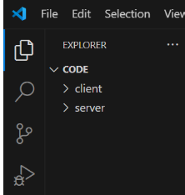
All backend code will be placed inside this folder.
Step 4: Initialize Node.js:
Open the terminal inside the server folder and run:
npm init -y
This creates a package.json file.
The package.json file contains information about the project and the packages used by the application.
Step 5: Install Required Packages:
Install the main packages:
npm install express mongoose dotenv bcryptjs jsonwebtoken cors
These packages are used for:
Package | Purpose
Express | Creates the backend server and APIs
Mongoose | Connects Node.js with MongoDB
dotenv | Loads environment variables
bcryptjs | Protects user passwords
jsonwebtoken | Provides JWT authentication
cors | Allows communication between different applications
For development, install Nodemon:
npm install --save-dev nodemon
Nodemon automatically restarts the server when code changes are made.
Environment Variables:
Sensitive information should not be directly written inside the source code.
Instead, it is stored in a .env file.
Example:
PORT=5000
MONGO_URI=mongodb://localhost:27017/aifittrack
JWT_SECRET=your_secret_key
GEMINI_API_KEY=your_google_gemini_api_key
Epic 3: Backend Development:
The backend is developed to provide APIs for:
- User authentication
- Workout management
- Workout searching
- AI recommendations
- Fitness insights
- Database operations
Main Backend Modules:
- Server Configuration
- Database Configuration
- Authentication
- Workout Management
- AI Recommendation
- Middleware
- Error Handling
All these modules work together to provide the complete FitTrack AI backend.
Epic 4: Database Configuration:
FitTrack AI uses MongoDB as its main database.
MongoDB stores application information in collections.
The project mainly uses two collections:
- Users
- Workouts
MongoDB stores information in document format, which is similar to JSON.
Mongoose:
Mongoose is used to connect the Node.js application with MongoDB.
Install it using:
npm install mongoose
Mongoose helps with:
- Creating data structures
- Validating data
- Connecting to MongoDB
- Performing database operations
- Managing relationships between data

MongoDB Connection
The database connection is usually kept in:
config/db.js
This file connects the backend application to MongoDB when the server starts.
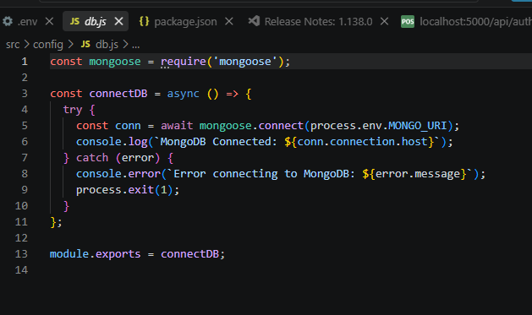
Responsibilities:
- Connect to MongoDB
- Detect connection errors
- Show connection status
- Provide the database connection to the application
Advantages:
- Database connection is managed in one place
- The connection can be reused
- Easier error handling
- Cleaner project structure
Mongoose Schemas:
Fit Track AI has two main schemas:
- User Schema
- Workout Schema
A schema defines what information can be stored and what rules the data must follow.
1. User Schema:
The User Schema stores information about registered users.
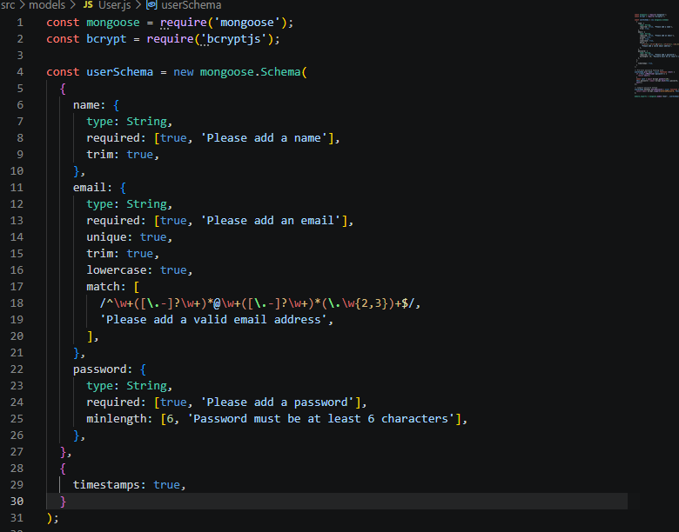

Rules:
- Name cannot be empty.
- Email must be unique.
- Password is required.
- Password is protected using bcrypt.js.
- Created and updated dates are automatically stored.

Main Features:
- Secure password storage
- Email validation
- Automatic timestamps
- Support for JWT authentication
Simple Example:
User
├── Name
├── Email
├── Password
├── Created Date
└── Updated Date

2. Workout Schema:
The Workout Schema stores the user's workout information.
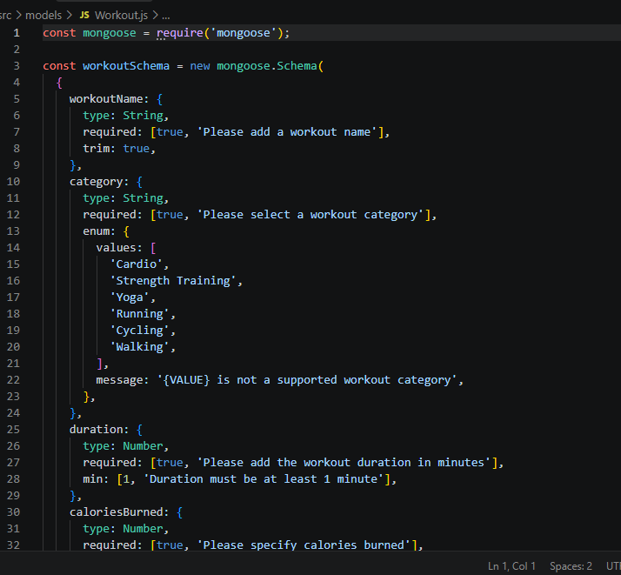
Rules:
- Workout name is required.
- Workout category is required.
- Duration must be greater than zero.
- Calories burned cannot be negative.
- Workout date is required.
- Every workout must belong to a user.

Main Features:
- Data validation
- Automatic timestamps
- Connection with User
- Easy workout searching
- CRUD operations
Simple Example:
Workout
├── Workout Name
├── Category
├── Duration
├── Calories Burned
├── Workout Date
└── User ID
The User ID connects the workout to the person who created it.
Project Execution:
After completing the backend development, the server can be started using:
npm start
The backend will then start running on the configured port.
For example:
http://localhost:5000

API Testing:
API testing is done to make sure that all backend APIs are working correctly.
Tools such as Postman or Thunder Client can be used to test the APIs.
Testing is generally performed in this order:

1. Authentication APIs
Test:
- Register
- Login
- Profile

2. Workout APIs
Test:
- Add workout
- View workouts
- Search workouts
- Update workout
- Delete workout

3. AI APIs
Test:
- Workout recommendation
- Fitness insights

Authentication API Testing:
Register User:
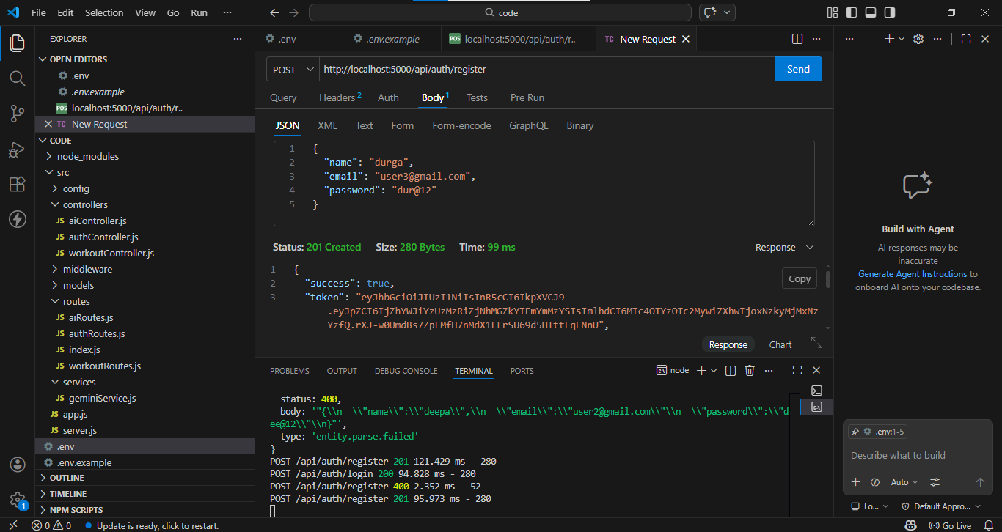
Login User:

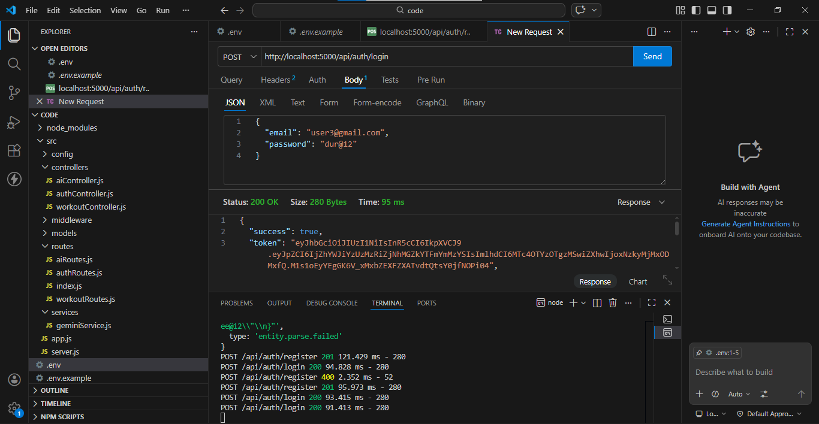

Get Profile:

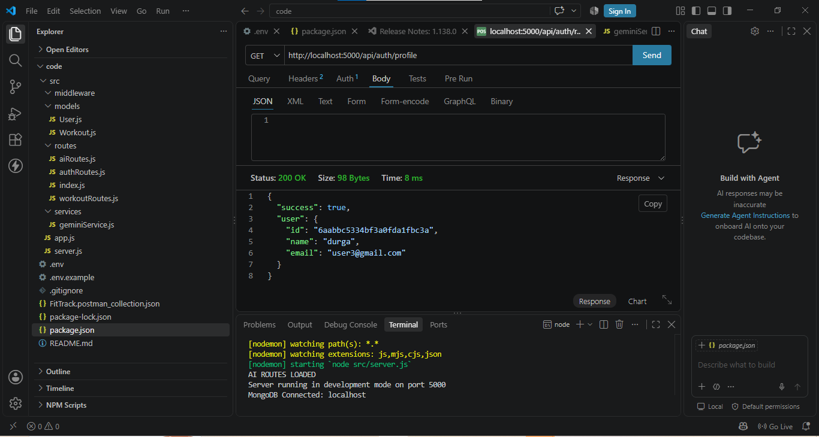

Workout API Testing:

Add
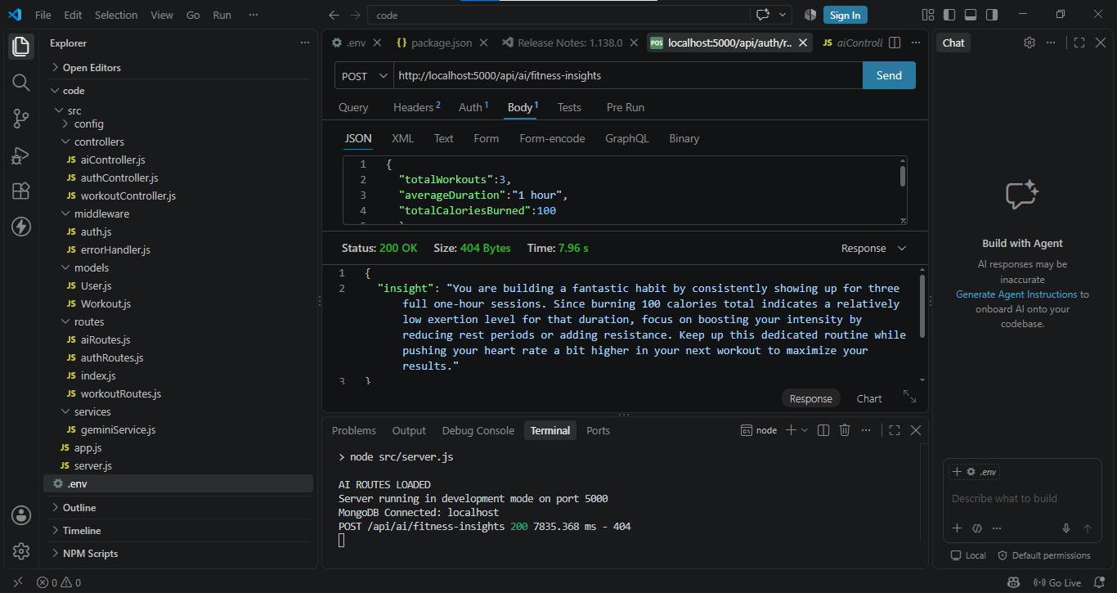
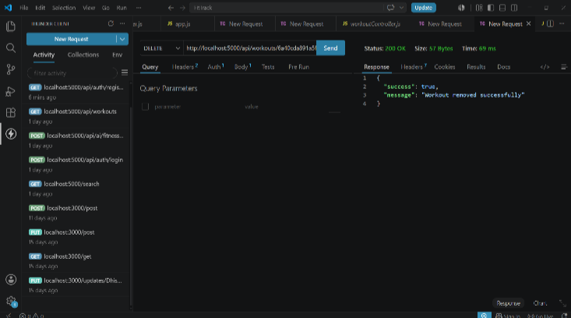
Get All:

Workout Recommendation:

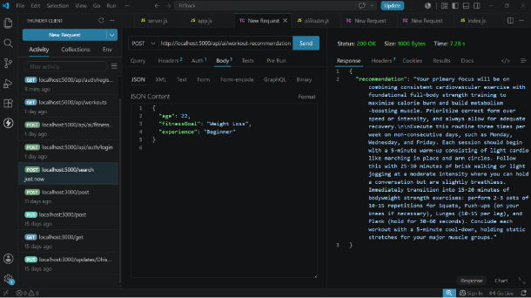

Fitness Insights:

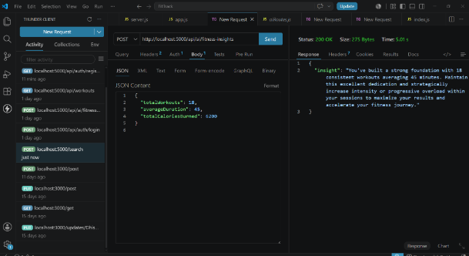

Conclusion
Fit Track AI makes workout tracking simple and easy for users.
It securely manages user accounts and workout information.
JWT and bcrypt.js help protect user data and passwords.
Google Gemini AI provides personalized workout suggestions and fitness insights.
The MVC architecture makes the backend organized and easy to maintain.
The system can be extended with new fitness features in the future.

